Emulsion tube for diesel engines VW 2.0 tdi pump injector

There are frequent queries about a plastic part on the cylinder head.
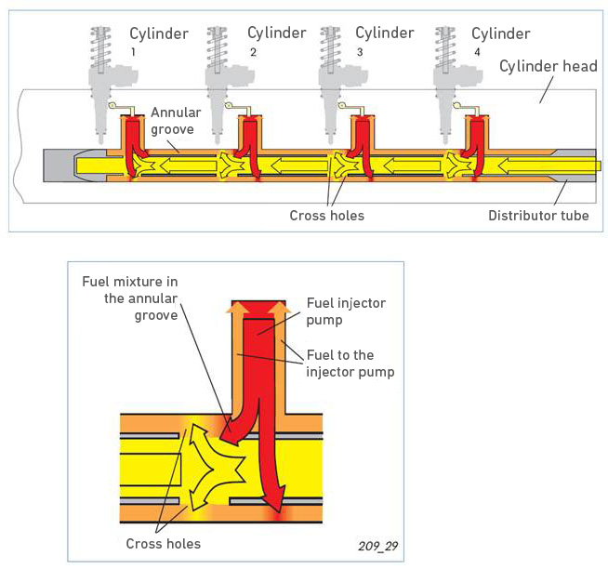
Just as we indicated on technical sheet 570229, which is included with the cylinder head, this tube must be removed from the old cylinder head and mounted on the new one.
The cylinder head feed line includes a distributor pipe. This uniformly distributes fuel to the pump injectors.
The fuel pump drives the fuel to the cylinder head feed line.
Fuel flows in the feed line inside the distributor pipe in direction of cylinder 1. There are transversal drill holes through which the fuel flows to the ring slot between the distributor pipe and the cylinder head. Fuel is mixed here with the hot fuel combustible, which is returned by the pump injectors to the feed line. This results in a uniform fuel temperature in the feed line for all cylinders. All pump injectors are fed with the same fuel mass, thus achieving uniform cyclic engine speed.
Without this distributor pipe there would not be a uniform fuel temperature in the pump injectors.
The hot fuel returned by the pump injectors to the feed line is driven by the fuel fed into cylinder 4 area towards cylinder 1.
In this way, cylinder 4 temperature rises with respect to cylinder 1 and the pump injectors are receiving furl at a uniform temperature. The consequences would be irregular engines speeds and excessive temperature in the front cylinders.
